H14619: Classical Greek Tragedy
El Hudson
ehudson@wellesley.edu
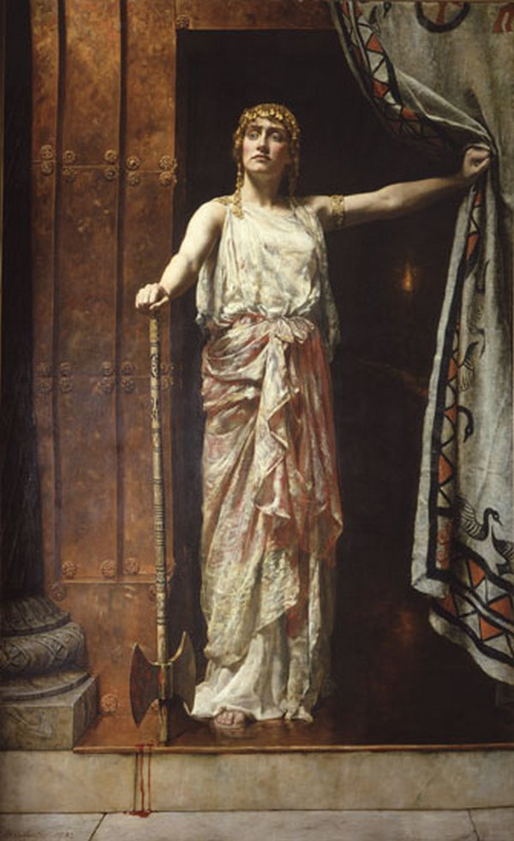

“Why does tragedy exist? Because you are full of rage. Why are you full of rage? Because you are full of grief.”

- Anne Carson, Grief Lessons: Four Plays by Euripides

Overview

What is tragedy, and why does it have such staying power? This course is dedicated to an interrogation of the form, function, structure, and above all meaning of tragedy. Our investigation will focus on the birth of tragedy as a genre: that is, the Greek city of Athens in the 5th century B.C.E, and specifically her three most well-known playwrights. In reading works by Aeschylus, Sophocles, and Euripides, we’ll trace the formation of Attic tragedy from the dawn to the dusk of classical Athens, and craft a definition of tragedy based on our conclusions.

Expectations & Format

Each week, there will be assigned readings of Greek tragedies in English. I’ll upload these to the class Google drive, as well as emailing them to the class mailing list. You can also find the readings listed on the syllabus below. Students are expected to come to class prepared to discuss the week’s reading.

This is a discussion-based course, meaning that the majority of class time will involve a conversation between all of you, guided by me. I’ll give a quick introductory lecture at the beginning of each class on the content and common interpretations of the week’s reading, and then turn it over to you.

A note of warning. Greek tragedy is often…intense; the plays we’ll be reading include topics such as intra-family murder, generational trauma, rape & other forms of violence against women, and suicide. I’ll provide content warnings both as a preface to the reading when it’s assigned, and at the beginning of each class. There’s no shame in not wanting to engage with such content, or in finding it upsetting; it is perfectly all right to either skip the session in question entirely, or take a moment to yourself during class.

In the same vein, I expect all members of this class to be mature & respectful of one another, especially when discussing sensitive topics. Cruelty, bullying, and bigotry of any stripe (racism, sexism, homophobia, et cetera) will not be tolerated.

Schedule

July 10

July 17

July 24

July 31

July 24

July 31

Act 1 | Aeschylus

The House that Dripped Blood
Aeschylus, Agamemnon (trans. Ian Johnston)

Destiny’s Garden
Aeschylus, Libation Bearers (trans. Ian Johnston)
Aeschylus, Kindly Ones (trans. Ian Johnston)
Recommended: Neil Gaiman, Kindly Ones (The Sandman vol. 9)

Act 2 | Sophocles

How is a Greek Chorus Like a Lawyer?
Sophocles, Antigone (trans. Jean Anouilh)
Recommended: Anne Carson, Antigonick

By Dread Things I am Compelled
Sophocles, Electra (trans. Mary Lefkowitz)
Recommended: Anne Carson, An Oresteia

Act 3 | Euripides

The Bloody Flesh our Only Food
Euripides, Bacchae (trans. Anne Carson)
Recommended: Euripides, Medea (trans. Rachel Kitzinger)

It is Not Done to Touch the Sick
Euripides, Orestes (trans. Anne Carson)

